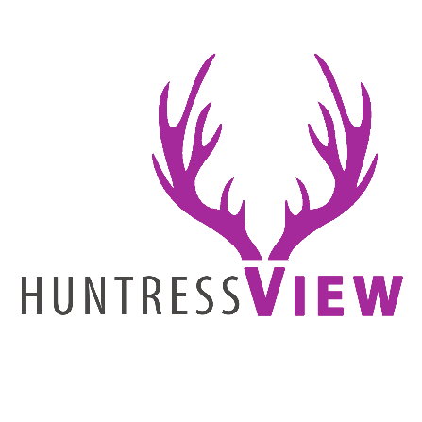
HUNTRESS VIEW TEAM APPLICATION
Thank you for your interest in joining the Huntress View team! We strive to represent ourselves and other women hunters in a positive light. At Huntress View we provide product reviews, hunting stories, tips and honest feedback on the products that are working for us with hopes of introducing more women to hunting and the outdoors.
CONTACT INFORMATION
Name:__________________________________ Phone number:_____________________
Address:________________________________ Date of Birth:_______________________
_______________________________________ Email:_____________________________
HUNTING EXPERIENCE
*If you consider yourself an AVID hunter of one or more of these categories, please place an “X” next to the category:
Deer_____ Elk_____ Turkey_____ Upland_____ Waterfowl_____ Bowfishing_____
Other (please specify):_____________

*How many years have you been hunting?

*What is your hunting experience?

*Have you ever introduced someone else to hunting, shooting or the outdoors? Explain.

*Have you ever been convicted of a Game Violation? If so please explain.

COMMUNITY AND SOCIAL MEDIA
*Are you currently sponsored or on any other outdoor companies’ staff? If so please list them.

*Do you belong to any conservation groups or clubs? (NWTF, DU, RMEF etc)

*What social media platforms do you currently use? Facebook? Twitter? Pinterest? Instagram? Please list the links/usernames below:

*Have you written any articles for any online publications or blogs? If so please list the links below:

ADDITIONAL CONSIDERATIONS
*What can you do to help promote/ grow Huntress View and portray women hunters in a positive light?

*Are you willing to submit articles for our blog on a regular basis?

*Anything else you would like us to know about you in considering your approval to our team?

DEADLINE
Please email this application along with any harvest photos by July 24th to huntressview@gmail.com

HUNTRESS VIEW

